AB WEBDESIGN
PRODUCTION
You can find the material on the server:
X:\2023\And Beyond\And Beyond Full Branding\08 Website\01 Webdesign\03 Services\02 Production
Color code: f8c113
Color code: 5c4199

Header
- Found in the “00 Headers” folder + add the following title “Production” in White
- Remove the social media titles
- Remove the sound feature
- Remove title “Start Engine”
- Replace “We create…” with following text:
It takes more than an idea and a strategy to give our clients the results they desire. Our heroes work together to differentiate our customers from their competitors. To see the results of the teamwork we have at And Beyond please take a glance at our projects!
- For Projects section you can find the images on the server:
X:\2023\And Beyond\And Beyond Full Branding\08 Website\01 Webdesign\03 Services\02 Production\01 Projects

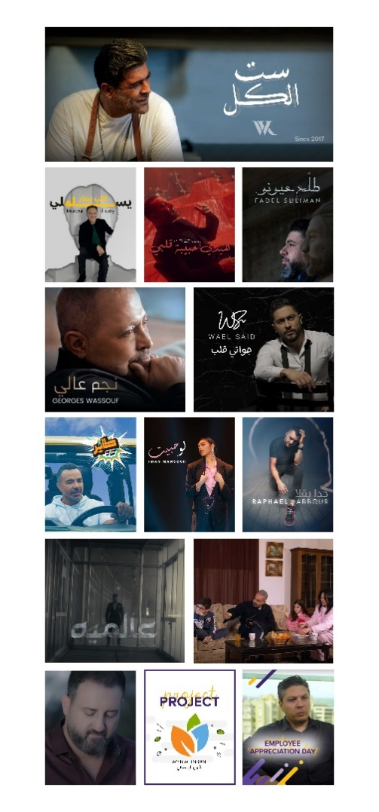
Visual Reference of how the projects should look:

Links: (left to right)
1- https://www.youtube.com/channel/UC1F4CV2YjvxKgNOOFqd_dfQ
2- مروان خوري - يسلملي اللي بيغار ( فيديو كليب ) | 2023 | Marwan Khoury - Yeslamli Li Bighar - YouTube
3- https://www.youtube.com/watch?v=1uR6w703jfM
4- https://www.youtube.com/watch?v=ZN_DCzCWNFM
5- https://www.youtube.com/watch?v=cwYI_HqTA3o
6- https://www.youtube.com/watch?v=MJdrghShmc4
7- https://www.youtube.com/watch?v=Y44I1oeyfQE
8- Iman Mansour - Law Habbayt ( Official Music Video 2023) | إيمان منصور - لو حبيت - YouTube
9- https://www.youtube.com/@RaphaelJabbour
10- Saif Nabeel - Aalamiya [Official Lyric Video] (2021) / سيف نبيل - عالميه - YouTube
11- Nusaned (NGO) - Support a Family TVC Campaign | جمعية نساند - إعلان لحملة مساعدة الأُسر - YouTube
12-Mahmoud Eid - Forgiveness | Music Video - 2020 | محمود عيد - YouTube
13-And Beyond - Digital Training Workshop (Amn Al Insani) | وبعد - ورشة تدريب رقمي (الأمن الإنساني) - YouTube
14- Fadel Corporate Video Production - Employee Appreciation Day | And Beyond - وبعد - YouTube

